STANDARD PROJECT GUIDELINES FOR ALL PROJECTS

Purpose of coding guideline
Coding guidelines help detect errors in the early stages, which reduces the additional cost of the software project.

Importance of coding standard and guidelines
Coding rules and guidelines ensure that software is: Safe: It can be used without causing harm. Secure: It can’t be hacked. Reliable: It functions as it should, every time.

Coding Standards in Software Engineering
General coding standards refers to how the developer writes code, so here we will discuss some essential standards regardless of the programming language being used.

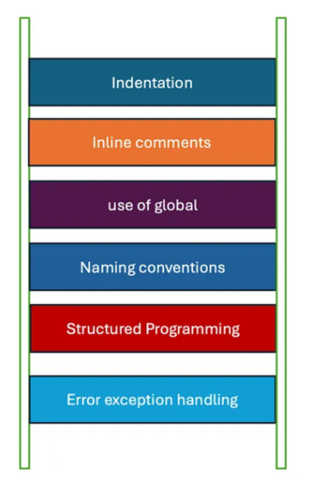

1. Indentation
Wrapping Lines
- Break after a comma.
- Break after an operator.
- Prefer higher-level breaks to lower-level breaks.
- Align the new line with the beginning of the expression at the same level on the previous line
White Spaces
- Here, we define the Tab as the standard indentation character.
- Do not use spaces for indentation — use tabs!
Blank Lines
Blank lines improve readability. They set off blocks of code which are in themselves logically related.
Two blank lines should always be used between:
- Logical sections of a source file
- Class and interface definitions (try one class/interface per file to prevent this case)
One blank line should always be used between:
- Methods
- Properties
- Local variables in a method and its first statement
- Logical sections inside a method to improve readability
Inter-term spacing
There should be a single space after a comma or a semicolon, for example:
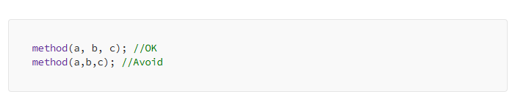
Table like formatting
Sometimes it is more readable to format a logical block of lines as a table:
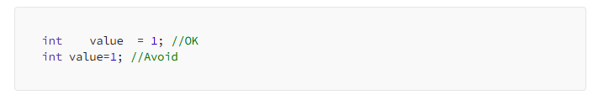

2. Inline comments
Internal code comments
- Single-line Code Comments: These are typically used to describe a single line or block of code directly above or next to the commented code.
- Multi-line Code Comments: Used for longer explanations that span multiple lines, often to describe complex logic or code that requires more in-depth clarification.
Documentation Comments
- All non-private classes, interfaces, methods and properties should have a documentation tag comment.
- These are structured comments used to generate documentation or provide comprehensive details about classes, methods, and functions.
- Different languages have specific formats and tools for generating documentation from these comments, like JSDoc for JavaScript, Javadoc for Java, and Sphinx for Python.

Best Practices for Comments and Documentation
- Be Concise but Clear: Write comments that are brief yet informative.
- Explain Why, Not What: Focus on the “why” behind the code, especially for complex logic.
- Keep It Updated: Always update comments and documentation when the code changes.
- Avoid Redundancy: Don’t restate the obvious; comments should add value beyond what is already clear from the code itself.
- Use Consistent Style: Follow a consistent commenting and documentation style throughout the project.

3. Global Variables Usage
- Minimize the use of global variables to avoid unintended side effects and conflicts.
- Prefer using constants and local variables within functions or classes.

4. Naming Conventions
- Use consistent naming patterns across the codebase.
- Use camelCase for variables and functions, PascalCase for classes, and UPPER_CASE for constants.
- Meaningful and understandable names to convey the purpose of the variable, function, or class.
- It is better to avoid the use of digits in variable names.

5. Structured Programming:
- Break down complex problems into smaller functions or modules.
- Ensure each function has a single responsibility and avoid large, monolithic functions.
- Use clear control flow structures like loops and conditionals to make the code easy to follow.

6. Error and Exception Handling
- Implement proper error handling to gracefully manage unexpected issues.
- Use try-catch blocks to handle exceptions and provide meaningful error messages.
- Avoid using exceptions for control flow; reserve them for handling exceptional conditions.

Coding Guidelines in Software Engineering
Coding guidelines give some general suggestions regarding the coding style that to be followed for the betterment of understandability and readability of the code.

Coding Guidelines
- Avoid difficult coding style : Code should be easily understandable.
- Follow the language specific style guide
- Code should be well documented and commented
- Follow the meaningful naming conventions
- Use consistent spacing and line breaks and limit the max number of char in single line
- Avoiding Code Smells: Length of function should not be large : Functions should be small enough to carry out small work
- Conduct code review to ensure quality
- Avoid the consistent use of third party library
- Avoide hard coding sensitive information in closing

5 pillars of code quality
The five pillars of code quality are fundamental principles that ensure software is maintainable, reliable, and efficient. These pillars help guide developers in writing high-quality code that is easier to understand, modify, and extend. The five pillars are:
- Readability: Improves code clarity, making it easier to understand for all developers.
Key Practices:
- Use clear and consistent naming conventions.
- Write self-explanatory code with proper comments where necessary.
- Follow a consistent code formatting style, including indentation and spacing.
- Break down complex logic into smaller, well-defined functions or methods.
2. Maintainability: The ease with which code can be modified or extended over time with minimal risk of introducing bugs.
- Facilitates easier maintenance and updates to the codebase.
Key Practices:
- Keep code modular and adhere to the Single Responsibility Principle (SRP).
- Refactor code regularly to reduce complexity and eliminate code smells.
- Write unit and integration tests to verify that changes do not break existing functionality.
- Use version control effectively to track changes and manage different versions of the code.
3. Reusability: The ability to reuse code components in different parts of the application or in other projects without modification.
Key Practices:
- Write modular and generic code that can be used across different contexts.
- Avoid hard-coding values; use parameters and configuration files instead.
- Adhere to the DRY (Don’t Repeat Yourself) principle to avoid code duplication.
- Design reusable components, libraries, and functions with clear and well-defined interfaces.
4. Reliability: The ability of code to perform its intended functions under defined conditions without failure.
Key Practices:
- Implement proper error handling and logging to detect and manage failures.
- Use thorough testing (unit tests, integration tests, and end-to-end tests) to catch issues early.
- Validate inputs and outputs to ensure data integrity and prevent unexpected behavior.
- Follow best practices for resource management to avoid memory leaks and crashes.
5. Performance Efficiency: The ability of code to execute efficiently, making optimal use of resources such as CPU, memory, and I/O.
Key Practices:
- Optimize algorithms and data structures for performance.
- Minimize unnecessary computations and avoid premature optimization.
- Use asynchronous programming where appropriate to improve responsiveness.
- Monitor and profile code to identify and address performance bottlenecks.

